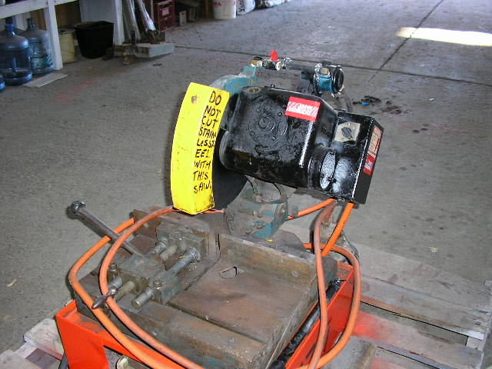 | Hazard Information Sheet
  Equipment: | Concrete and Masonry
 | Equip Type: | Saws
 | Generic Description or  Specific Make / Model: | Quick Cut Saw  (Drop or Hand held)
 | Type: | Electric or Petrol
 | Other Details

Operator Requirements: | Operators must be trained and competent to use this equipment safely. Operators using carbide tipped blades may be restricted by law and need special training.
Purpose For Which This Equip Is Designed: | For cutting rapidly through steel, concrete or stone when fitted with correct cutting disc.

Hazards & Risks:
Control Measures:
Cutting, Stabbing & Puncturing:  Kickback, pull-in and pinching/rotation. | (i) Always keep good balance and footing, and use both hands with a firm grip, thumb and fingers encircling both handles.  (ii) Never start saw with the disc in the cut. Do not cock, jam or wedge the wheel in the cut. Be careful when re-entering a cut.  (iii) Keep work at a comfortable distance and run saw at full throttle when cutting.  (iv) Never cut above shoulder height. Always start the cut-off saw on the ground, never in mid-air or one-handed.  (v) Be alert to shifting of work piece or anything that could cause the cut to close and pinch the disc. Support the work piece so that the cut will stay open during cutting and not close as this may pull the saw down suddenly with a strong turning motion.

Disclaimer: In fulfilment of its statutory obligations, (ARS) & John Holland has taken what it considers to be all reasonable precautions and exercised due diligence to ensure that it has provided all relevant information on the safe use of the plant. However, except as required by law and only to the extent so required, (ARS) & John Holland does not make any representation, warranty or undertaking, express or implied, as to, or accept any responsibility or liability for, the accuracy or completeness of, or any errors in or omissions from, this Hazard Information Sheet. Except as required by law and only to the extent so required, neither (ARS) & John Holland nor any of its respective directors, officers, agents, or employees shall in any way be liable directly or indirectly to any person or body for any loss or damages, costs or expenses whatever arising out of or in connection with the information contained in this Hazard Information Sheet. | Date: 19/06/06
Equipment: | Quick Cut Saw  Electric or Petrol

Hazards & Risks: | Control Measures:
Coming in contact with moving parts. | (i) Always handle saw carefully and remove cutting wheel before transporting or storing the saw.  (ii) Always operate with the disc guard in place.  (iii) Never operate the saw if the disc brake is not working i.e. disc does not stop rotating when the throttle trigger is released.  (iv) When using always ensure a firm hand grip and that handles/hand grip are in good condition, and free of moisture or oil.
Coming in contact with sharp or flying objects | i) Inspect new discs for damage before use.  (ii) Do not use a disc that has been dropped, bent or damaged in any way.  (iii) Do not use a disc with a maximum rpm rating lower than the rpm rating of the saw.
Carbide-tipped blades are designed to cut metals rather than grind away at them and can lose a tip if the blade suddenly hits harder material. | (i) Use of carbide-tipped blades may be restricted by law to specially trained operators and to special circumstances such as firefighting or emergency rescue work.  (ii) Use only approved carbide-tipped blades for hand-held cut-off saws. Use carbide- tipped blade only on cut-off saws that have a slip clutch.  (iii) Never operate a carbide-tipped blade unless you have had special instruction in its use and only use it when the situation warrants. Do not use on electric models.  (iv) Operators, assistants and bystanders within 100’ (30m) must wear safety goggles, helmet with full face shield, full protective clothing and steel toed safety boots.  (v) Keep bystanders and animals a minimum of 100’ (30’) away from work area.  (vi) Pay particular attention to starting procedures and to kickback which is more likely with carbide-tipped blades.  (vii) Never touch a rotating blade.

Disclaimer: In fulfilment of its statutory obligations, (ARS) & John Holland has taken what it considers to be all reasonable precautions and exercised due diligence to ensure that it has provided all relevant information on the safe use of the plant. However, except as required by law and only to the extent so required, (ARS) & John Holland does not make any representation, warranty or undertaking, express or implied, as to, or accept any responsibility or liability for, the accuracy or completeness of, or any errors in or omissions from, this Hazard Information Sheet. Except as required by law and only to the extent so required, neither (ARS) & John Holland nor any of its respective directors, officers, agents, or employees shall in any way be liable directly or indirectly to any person or body for any loss or damages, costs or expenses whatever arising out of or in connection with the information contained in this Hazard Information Sheet. | Date: 19/06/06
Entanglement (Guarding):  Limbs or clothing coming in contact with rotating disc. | Operator to wear proper clothing with leg protection (for sparks), heavy duty non-slip gloves, goggles, helmet with full face shield, steel toed safety boots, hearing protection (breathing mask or respirator, depending on work being done). Do not work alone.
Hazardous Substances:  Inhalation of hazardous dust. | Asbestos / other hazardous dust is extremely dangerous to health and specifically approved respirators are required which comply with OH&S regulations.
Electrical (Electric Saws Only):  Electric shock or burns due to damaged electrical leads and cables. | Operator to ensure no nicks, cuts or damage to electrical cord and plug before cable use. Use with RCD protected power supply.
Water near electrical equipment. | (i) Do not use in area where tool is likely to get wet.  (ii) When raining ensure tool is sheltered.  (iii) Ensure cord not positioned in or near water, nor likely to get damaged from falling objects, or pedestrian or other traffic.  (iv) When used outdoors, use extension cords designed for outdoor use only.  (vi) Never use water as a cutting agent/dust suppressor with an electric cut-off saw.
High Temperature or Fire:  Refuelling: When refuelling, sparks, naked flames or hot engine can ignite fuel. | Operator to stop engine before refuelling and allow it to cool. Refuel in a well ventilated area. Ensure no naked flames in the area. DO NOT SMOKE. Avoid spilling fuel, and collect any fuel run off. Never remove fuel filler cap while engine is running. Select bare ground for refuelling and move at least 10’ (3m) from the refuelling spot before starting the cut-off saw. Never use power tools near explosive or inflammable materials.
Coming into contact with hot parts. | Avoid touching the muffler or other hot parts.
Noise:  Exposure to noise. | Wear appropriate hearing protection if exposure to noise exceeds 85 dB(A).
Striking (Hitting):  Blades disintegrating. | (i) Never use damaged cut-off blades.  (ii) Don’t change direction of cut once started as this can cause wheel breakage.
Suffocation:  Suffocation due to lack of oxygen, or atmospheric contamination. | (i) Use confined space procedures where applicable.  (ii) If working in poorly ventilated areas monitor exhaust fumes at regular intervals (petrol units).
Equipment: | Quick Cut Saw  Electric or Petrol

Disclaimer: In fulfilment of its statutory obligations, (ARS) & John Holland has taken what it considers to be all reasonable precautions and exercised due diligence to ensure that it has provided all relevant information on the safe use of the plant. However, except as required by law and only to the extent so required, (ARS) & John Holland does not make any representation, warranty or undertaking, express or implied, as to, or accept any responsibility or liability for, the accuracy or completeness of, or any errors in or omissions from, this Hazard Information Sheet. Except as required by law and only to the extent so required, neither (ARS) & John Holland nor any of its respective directors, officers, agents, or employees shall in any way be liable directly or indirectly to any person or body for any loss or damages, costs or expenses whatever arising out of or in connection with the information contained in this Hazard Information Sheet. | Date: 19/06/06

